3GPP TSG RAN WG1 #125 R1-2604134
Dalian, China, May 18th ~ 22nd, 2026

Source: OPPO
Title: Discussion on waveform and frame structure for sensing
Agenda Item: 10.8.3
Document for: Discussion and Decision

Introduction
In RAN1#124-bis meeting, the following agreements were made for this agenda [1].
Agreement:
CP-OFDM waveform as defined for 6GR is the starting point for 6G ISAC waveform study.
Study on enhancements on CP-OFDM or other waveforms is not precluded.

Agreement:
6GR communication frame structure is the starting point for 6G ISAC frame structure study, in at least the following aspects.
- Frame/sub-frame/slot/symbol structure
- CP length
- SCS
Enhancements on frame structure/above aspects are not precluded.

Agreement:
Companies are encouraged to provide views on necessity/pros/cons/metrics of LLS and/or SLS and pros/cons/metrics of theoretical waveform characteristics analysis, for evaluation of ISAC waveform and/or integration with communication, to RAN1#125 meeting.

Agreement:
CP-OFDM is used as the benchmark for evaluating the benefits of sensing waveforms.

This contribution gives our initial views on waveform and frame structure design.

Waveform

Analysis on existing communication waveforms
As described in our companion paper under agenda 10.5.0 [2], a modular design can be taken for 6GR air interface. To be more specific, as shown in Fig. 1, a low-cost and energy-efficient “Basic function set” can be designed for 6GR air interface, which serves as a "common basis" for various usage scenarios. For a specific usage scenario, like sensing, a full functionality set can be designed which “grows up” from this basic functionality set, perhaps with the help of upgraded vertical functionality set.
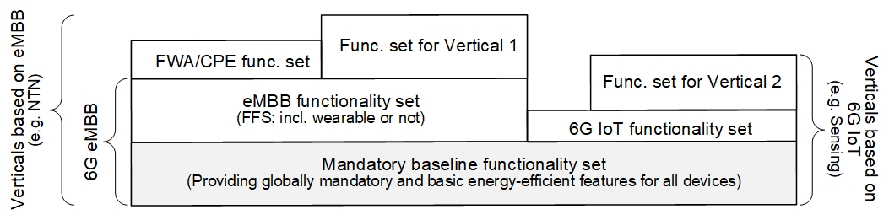
Fig. 1. Scalable 6GR with Mandatory baseline functionality set
If physical designs can be shared between the basic functionality set and the vertical functionality set for sensing, it will simplify the system design, and is also beneficial for the commercial deployment of sensing. Besides, in the design of 6G ISAC waveforms, it is essential to recognize the deep coupling of sensing and communication, for the two services jointly utilize time-frequency resources. Therefore, the existing waveform used for communication should be taken at least as a starting point.
Note that for communication, there are two existing waveforms, CP-OFDM and DFT-S-OFDM. In downlink, only CP-OFDM is used. In uplink, both CP-OFDM and DFT-S-OFDM can be configured, while DFT-S-OFDM is mainly used for data transmission. This is because for deterministic signals such as reference signal, it does not matter whether the signal is mapped on time-domain or frequency domain. All a receiver can see is the frequency-domain sequence. However, for data signal, whether it is mapped on time-domain or frequency-domain makes quite a difference, since the receiver needs to convert the received signal to the correct domain to properly demodulate it.
Proposal 1: Given a SRX can perform target channel measurements by using the equivalent sensing RS signal in frequency domain even if the sensing signal on STX side is firstly generated in time domain and transmitted in DFT-s-OFDM waveform, there seems no strong motivation to additionally study DFT-S-OFDM for sensing detection.

Pulse waveform
As a continuous waveform, CP-OFDM may face challenges in some cases. For instance, using CP-OFDM for mono-static sensing requires simultaneous Tx & Rx, which can cause severe self-interference. One possible solution to avoid self-interference is to make Tx and Rx TDM, which means that the TRP can firstly transmit a pulse-like waveform, and then receives the reflected waveform from the sensing target. Besides, it would be better if this pulse-like waveform fits into one OFDM symbol.
We think the comb-like frequency structure can be utilized to generate pulse-like waveform. Comb structure in frequency-domain will cause repetitions in time-domain, while one of the repetitions may be transmitted as pulse in the transmit window. Then, the Tx part can remain silent outside the transmit window within the OFDM symbol, as shown in Fig. 2.
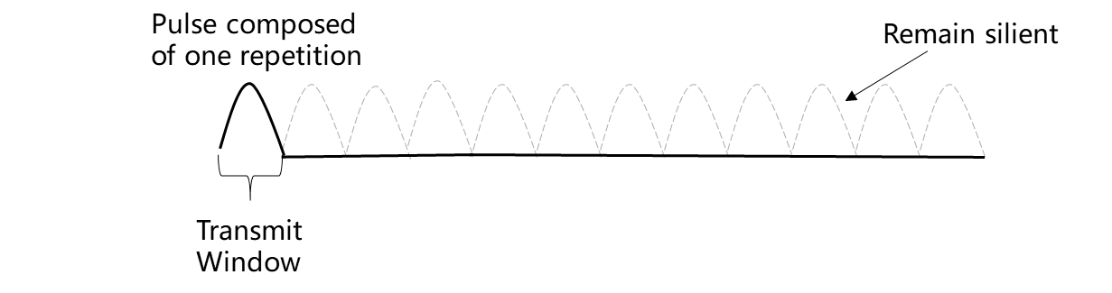
Fig. 2. Pulse-like waveform composed of one repetition within one OFDM symbol
What’s more, the time-domain waveform within the transmit window is also CP-OFDM waveform. Let’s assume that the channel bandwidth contains altogether $K$ subcarriers, and the comb-number is $L$. Then, the time domain waveform within the transmit window can be expressed as $y=\sum_{k=0}^{K}{x_{k}e^{j2πkΔft}}$, with $-T_{cp}≤t≤\frac{T}{L}$. Since the transmitted signal has a comb-structure, $x_{k}≠0$ only if $k=k^{'}L$, where $k^{'}$ can be interpreted as the subcarrier index within the Comb-RE. Then, after some mathematical manipulations, we have $y=\sum_{k^{'}=0}^{K/L}{x_{k^{'}}e^{j2πk^{'}(LΔf)t}}$, which is equivalent to having a CP-OFDM waveform with a larger SCS of $LΔf$. As a result, this can bring convenience for designing the pulse-like waveform based on CP-OFDM.

Note that pulse-like waveform is detrimental to sensing nearby targets, as the sensing node can only receive the reflected waveform after the transmission is finished. Therefore, the pulse-width needs to be carefully designed. Fortunately, with the design of comb-number $L$, we can have a flexible pulse-width that is suitable for various scenarios.

Proposal 2: To avoid self-interference for mono-static sensing, a pulse-like waveform can be designed based on comb structure in frequency domain
- Frequency domain comb-size can be designed to offer a pulse-width flexibility.

Additional waveforms
From our perspective, other waveform enhancements or additional waveforms specific for 6G Sensing can be considered. However, there should be a strong motivation, or significant gain can be justified. In any case, the fewer the modifications made to the CP-OFDM waveform, the better for deploying a 6G network shared by communication and sensing. In addition, it is worth pointing out that the sensing-specific waveform enhancement, or additional waveforms, if accepted, will not be used for 6G communication.
Proposal 3: Other enhancements or additional waveforms for 6G sensing can be studied
- There should be a strong motivation or significant gain for justification
- The sensing-specific waveform enhancement or additional waveforms, if accepted, will not be used for 6G communication.

Evaluations on different waveforms
Waveform characteristics
The waveform characteristics can include Tx power gain, and ambiguity function related characteristics like main lobe width, PSLR (Peak Sidelobe Ratio) or ISLR (Integrated Sidelobe Ratio). These characteristics have long been used to evaluate waveforms. Specifically, the Tx power gain may come from two aspects. The first aspect is the PAPR gain, and the second aspect is the TDMed Tx & Rx for mono-static sensing, where saturation of the Rx is not worried anymore.
Proposal 4: Tx power gain and ambiguity function can be considered to evaluate sensing waveforms.
However, the results waveform characteristics can give may be regarded as intermediate. Besides, different waveforms may exhibit distinct performances under various metrics. For instance, a certain waveform may have good PAPR performance but comes with a wide main lobe, while others may possess a narrow main lobe but suffer from strong sidelobes. In this case, it is difficult to compare different waveforms in terms of the above-mentioned waveform characteristics.
Link-level-simulation
Therefore, simulations can be considered to compare the sensing performance of different waveforms, and we think link-level simulation (LLS) is more appropriate than the system level counterpart. For LLS, perhaps there are two questions that we need to answer at first, including “what is the recommended link-level channel model”, and “what are the corresponding metrics”.
For the link-level channel model, there have been some discussions in R19, which ends in a conclusion saying that no enhancement to existing LLS channel model is introduced:
Conclusion in RAN1 #121
Delete subsection 7.9.6 from the draft CR. For ISAC, no enhancement to existing TR38.901 LLS channel model is introduced in Rel-19.
Accordingly, we think that, to take the existing link level channel model for communication (e.g., CDL model), at least as a starting point for sensing, may serve as a straightforward way. To be more specific, since the original motivation for LLS is to compare the performance of waveforms, not to evaluate performance KPIs for sensing, only necessary modifications to the existing LLS channel model are accepted. For instance, a distant-related delay offset may be added to the cluster delays to account for the absolute delay of the channel.
As usual, the metrics at least include accuracy for delay and/or Doppler. For a given SNR, those two accuracies can be compared for different waveforms. Note that the signal power here could be the average signal power within a certain time, e.g., within one OFDM symbol.
Besides, what we want to draw attention here is that angle may not be listed as one of the metrics, since it seldom has anything to do with the baseband waveform. And as angle is not included, positioning/locating may not be considered either in this point-to-point LLS.
As we have discussed in 5GA ISAC, angle estimation mainly relies on the phases on different antennas. However, the phases on different antennas used for angle estimation is only relevant to the carrier frequency/wavelength. This can be shown from the existing channel model in TR 38.901 [3] (which is also copied below). To be more specific, $λ_{0}$in the phase term in formula 7.9.4-4 is carrier wavelength, and it has nothing to do with the baseband waveform discussed in this agenda. Therefore, we think there is no strong need to evaluate angle estimation/target locating for baseband waveform.
Step 14: Generate channel coefficients for paths in set R for each receiver and transmitter element pair u, s.
The channel coefficient for a path $(k,p,n^{'},m^{'},n,m)$ in set R is generated by
$$H_{u,s,n^{'},m^{'},n,m}^{k,p}\left(t\right)=\sqrt{P_{n^{'},m^{'},n,m}^{k,p}}{\left[\begin{matrix}F_{rx,u,θ}\left(θ_{rx,n^{'},m^{'},ZOA}^{k,p},ϕ_{rx,n^{'},m^{'},AOA}^{k,p}\right) \\ F_{rx,u,ϕ}\left(θ_{rx,n^{'},m^{'},ZOA}^{k,p},ϕ_{rx,n^{'},m^{'},AOA}^{k,p}\right)\end{matrix}\right]}^{T}\frac{C{PM}_{rx,n^{'},m^{'}}^{k,p}{CPM}_{n^{'},m^{'},n,m}^{k,p}{CPM}_{tx,n, m}^{k,p}}{\sqrt{{\left({\left|d^{θθ}\right|}^{2}+{\left|d^{ϕϕ}\right|}^{2}\right)}/2}}$$
$∙\left[\begin{matrix}F_{tx,s,θ}\left(θ_{tx,n,m,ZOD}^{k,p},ϕ_{tx,n,m,AOD}^{k,p}\right) \\ F_{tx,s,ϕ}\left(θ_{tx,n,m,ZOD}^{k,p},ϕ_{tx,n,m,AOD}^{k,p}\right)\end{matrix}\right]\exp\left(j2π\frac{{\hat{r}}_{rx,k,p,n^{'},m^{'}}^{T}\left(\tilde{t}\right).{\bar{d}}_{rx,u}+{\hat{r}}_{tx,k,p,n,m}^{T}\left(\tilde{t}\right).{\bar{d}}_{tx,s}}{λ_{0}}\right)\exp\left(j2π\int_{t_{0}}^{t}{f_{D,n^{'},m^{'},n,m}^{k,p}\left(\tilde{t}\right)d\tilde{t}}\right)$ (7.9.4-4)
Proposal 5: Link level simulation can be considered to evaluate sensing waveforms
- Use LLS model in 38.901 (e.g., CDL) that is used for communication purpose, with necessary modifications for target channel and/or channel delays
- Corresponding metrics include accuracies for delay and/or Doppler
- No strong reason to evaluate angle detection and target locating

Frame Structure

Design principles for Frame Structure
In our view, the frame/slot structure designed for communication can be reused for 6G sensing. This means that sensing signals are to be transmitted in the frame/slot structure originally designed for communication. Note that sensing can have its own waveform/RS(s) transmitted in a symbol. However, these sensing related designs need to smoothly fit into the frame/slot structure designed for communication. When talking about “smoothly fitting into frame/slot structure designed for communication”, one possible way is that symbol boundary in frame/slot structure designed for communication is not impacted by sensing. In this way, the frame/slot structure can remain unchanged.
Observation 1: With the same symbol boundary as communication, frame/slot structure can remain unchanged.
Besides, another reason for maintaining symbol boundary is that, it can minimize the impact on other UEs, especially on those UEs without sensing requirements or services. Let’s consider a communication UE receiving periodic CSI-RS. For instance, the periodic CSI-RS may lie in the eighth symbol of a periodic slot. For a slot containing sensing symbol, if the symbol boundary changes, the time-domain of the eighth symbol in this slot may be different from that in a slot without sensing symbol, as shown in Fig. 3. To successfully receive CSI-RS, UE may need to be aware of the existence of sensing symbol, though it has no sensing service. It is better to avoid this kind of effect on those non-sensing UEs.
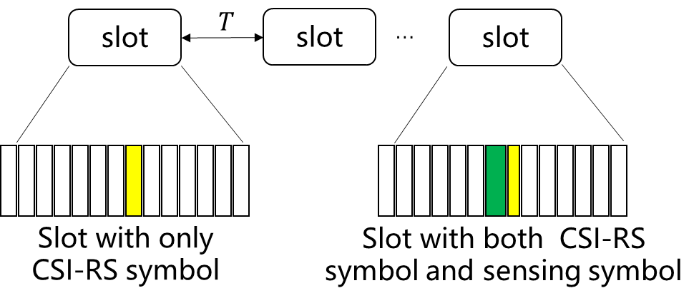
Fig. 3. The time-domain of the symbol may be different
Observation 2: Without the same symbol boundary, other non-sensing UEs may be impacted.
In addition, the frame/slot structure designed for communication supporting semi-static assignment for transmission direction (e.g., semi-static TDD/FDD/SBFD) is assumed to have enough flexibility to support various sensing waveform/RS configurations. It is also worth pointing out that we do not preclude the way that communication signal and sensing signal are multiplexed on one symbol for e.g., better utilization of resources.
Proposal 6: Reuse the frame/slot structure designed for communication for 6G sensing
- For a symbol containing a sensing signal, its symbol boundary remains unchanged from the communication perspective
  - Multiplexing of communication and sensing on this symbol is not precluded.

Analysis on longer CP
For 6G sensing, CP-OFDM serves as a starting point for waveform design. In this way, sensing and communication can be better deployed in the same system. However, since the scenarios for sensing and communication differ from each other, some enhancements may need to be made to the frame structure. Moreover, it is worth pointing out that making enhancements does not necessarily mean making changes. We think it is better to implement them in an equivalent manner, rather than directly changing the frame structure.
To be more specific, one notable distinction between sensing and communication is that: sensing involves mono-static operation, while communication nearly always assumes bi-static transmission. Unlike CP in bi-static transmission, which is mainly used to cover relative delay, CP in mono-static mode needs to cover absolute delay between the Tx waveform and the reflected Rx waveform. This is partly because there is no pre-synchronization between the Tx part and the Rx part of a same node. As shown in the following Fig. 4, a longer CP is thus needed, to ensure that the sensing node (e.g., a TRP) receives the complete payload of one OFDM symbol in the Rx window. Note that the length of the CP should be longer than the absolute delay caused by a distant target.
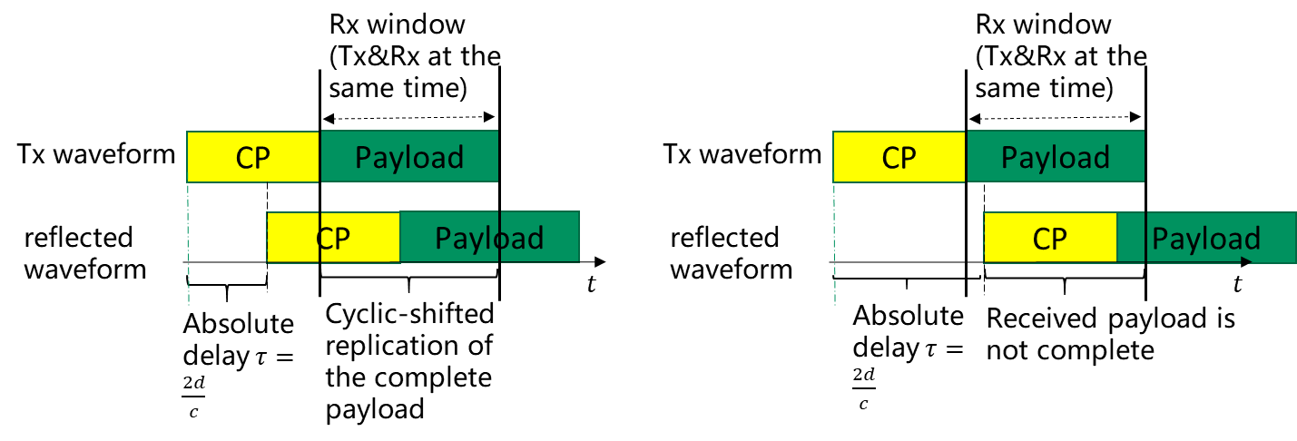
Fig. 4. Necessity of long CP to cover the absolute delay
It is worth pointing out that, due to back-and-forth reflection of the sensing waveform under mono-static sensing mode, the absolute delay between the reflected Rx waveform and the Tx waveform is the round-trip time, which could be quite large for scenarios like RMa. For instance, for a ISD of 1732m, the absolute delay caused by a flying UAV may reach $2×\sqrt{{1732}^{2}+{300}^{2}}÷\left(3×{10}^{8}\right)≈11.7$us, which is larger than the current CP length of 2.34us for 30kHz SCS.
In addition, for bi-static sensing mode, it is also possible that the sensing target is far away. It is likely that the time delay difference between the first arrival path and the target path is larger than the length of a normal cyclic prefix (CP).
Observation 3: Sensing may need a longer CP than communication, due to the following reasons:
- In case of mono-static sensing, a longer CP may be needed to cover the absolute round-trip delay
- In case of bi-static sensing, a longer CP may be needed to cover the delay difference of the first arrival path and the target path

Potential solutions to achieve longer CP
One potential solution is to simply extend the CP length of the OFDM symbol carrying sensing signal. However, this may break the OFDM symbol boundary from the communication perspective. A better way could be to enable an equivalent longer CP without changing the symbol boundary.
There are two possible methods to achieve this. On one hand, a single symbol-based method can be considered. To be more specific, on this single symbol, a comb-based frequency pattern can construct repetition in time-domain, where the repetition and the normal CP can equivalently serve as a longer CP. Since a comb-based frequency pattern is needed, the sensing waveform may be vulnerable to interference, and is not convenient for frequency-domain multiplexing. As a result, when there are several TRPs at close distances performing mono-static sensing simultaneously, code-domain multiplexing may be needed.
On the other hand, a double symbol-based method can be considered. To be more specific, the first symbol of a pair of symbols can help to form an equivalent longer CP for the second symbol, as shown in the following figure. Note that double-symbol based method can enable a longer CP than the single-symbol counter-part, and is more convenient for frequency-domain multiplexing.
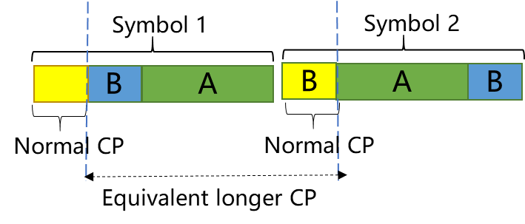
Fig. 5. Double symbol-based method to achieve longer CP

Proposal 7: Two methods can be considered to enable equivalent longer CP without changing the symbol boundary
- A single-symbol based method, where the comb-based frequency-domain pattern enables longer CP in time-domain
- A double-symbol based method, where the first symbol contributes to form a longer CP

Conclusions
This contribution concludes with the following observations and proposals.
For the study of waveform:
Proposal 1: Given a SRX can perform target channel measurements by using the equivalent sensing RS signal in frequency domain even if the sensing signal on STX side is firstly generated in time domain and transmitted in DFT-s-OFDM waveform, there seems no strong motivation to additionally study DFT-S-OFDM for sensing detection.
Proposal 2: To avoid self-interference for mono-static sensing, a pulse-like waveform can be designed based on comb structure in frequency domain.
- Frequency domain comb-size can be designed to offer a pulse-width flexibility.
Proposal 3: Other enhancements or additional waveforms for 6G sensing can be studied
- There should be a strong motivation or significant gain for justification
- The sensing-specific waveform enhancement or additional waveforms, if accepted, will not be used for 6G communication.
Proposal 4: Tx power gain and ambiguity function can be considered to evaluate sensing waveforms.
Proposal 5: Link level simulation can be considered to evaluate sensing waveforms
- Use LLS model in 38.901 (e.g., CDL) that is used for communication purpose, with necessary modifications for target channel and/or channel delays
- Corresponding metrics include accuracies for delay and/or Doppler
- No strong reason to evaluate angle detection and target locating
For the study of frame structure:
Observation 1: With the same symbol boundary as communication, frame/slot structure can remain unchanged.
Observation 2: Without the same symbol boundary, other non-sensing UEs may be impacted.
Proposal 6: Reuse the frame/slot structure designed for communication for 6G sensing
- For a symbol containing a sensing signal, its symbol boundary remains unchanged from the communication perspective
  - Multiplexing of communication and sensing on this symbol is not precluded.
Observation 3: Sensing may need a longer CP than communication, due to the following reasons:
- In case of mono-static sensing, a longer CP may be needed to cover the absolute round-trip delay
- In case of bi-static sensing, a longer CP may be needed to cover the delay difference of the first arrival path and the target path

Proposal 7: Two methods can be considered to enable equivalent longer CP without changing the symbol boundary
- A single-symbol based method, where the comb-based frequency-domain pattern enables longer CP in time-domain
- A double-symbol based method, where the first symbol contributes to form a longer CP

References
- Chair notes RAN1#124bis
- R1-2604111, General aspects and frameworks for 6GR multi-antenna system, OPPO
- 3GPP TR 38.901, Study on Channel Model for Frequencies from 0.5 to 100 GHz, v19.0.0

